# **CHAPTER 2**

# **LITERATURE REVIEW**

# **Introduction**

The heart is the organ that responsible for pumping blood throughout the body. It

is located in the middle of the thorax, slightly offset to the left and surrounded by the

lungs basically; the human heart is composed of four chambers which are two atriums

and two ventricles. The right atrium receives blood returning to the heart from the whole

body. That blood passes through the right ventricle and is pumped to the lungs where it is

oxygenated and goes back to the heart through the left atrium, and then the blood passes

through the left ventricle and is pumped again to be distributed to the entire body through

the arteries.

A heart attack happens when there is a sudden complete blockage of an artery that

supplies blood to an area of your heart. A heart is a muscle, and it needs a good blood supply

to keep it healthy. As we get older, the smooth inner walls of the arteries that supply the

blood to the heart can become damaged and narrow due to the build up of fatty materials,

called plaque. When an area of plaque breaks, blood cells and other parts of the blood stick to

the damaged area and form blood clots.

A heart attack occurs when a blood clot completely blocks the flow of blood and

seriously reduces blood flow to the heart muscle. This also results in patients experiencing

chest pain. As a result, some of the heart muscle starts to die. The longer the blockage is left

untreated, the more the heart muscle is damaged. If the blood flow is not restored quickly,

the damage to the heart muscle is permanent. A heart attack is sometimes called a

myocardial infarction (MI), acute myocardial infarction, coronary occlusion or coronary

thrombosis.

# **Detect and effect of heart attack**

Some heart attacks are sudden and intense. But most start slowly, with mild pain or discomfort. Here are some of the signs that can mean a heart attack is happening:

• Chest discomfort.

Most heart attacks involve discomfort in the center of the chest that lasts  
more than a few minutes, or that goes away and comes back. It can feel like uncomfortable pressure, squeezing, fullness or pain.

• Discomfort in other areas of the upper body.

Symptoms can include pain or discomfort in one or both arms, the back, neck, jaw or stomach.

• Shortness of breath.

May occur with or without chest discomfort.

• Other signs:

These may include breaking out in a cold sweat, nausea or lightheadedness.

As with men, women’s most common heart attack symptom is chest pain or discomfort. But women are more likely than men to have some of the other common symptoms, particularly shortness of breath, nausea/vomiting, and back or jaw pain.

# **Review of Existing System**

* + 1. **Instant Heart Rate Apps**

Instant Heart Rate is the most accurate Heart Rate Monitor app for any smartphone, and it does not need any external hardware. Accuracy is constantly tested by fitness coaches, nurses, doctors, EMTs and 5 million users like you. Use it for optimizing your exercise and to track your progress.

Instant Heart Rate also measures your heart rate by analysing your tip of the Index finger using the phone’s camera. To monitor your heart rate you have to place your finger tip in the camera lens. This app will analyse and track your heart rate. The Heart rate will appear in the screen after some time.

A real-time chart will show your every heart beat. It uses your phones built-in camera to track color changes on the fingertip that are directly linked to your pulse. This is the same technique that medical pulse oximeters use. For the best result use this good lighting condition, if your phone doesn’t have a flash light.

Figure 2.1 show the interface for Instant heart rate apps.

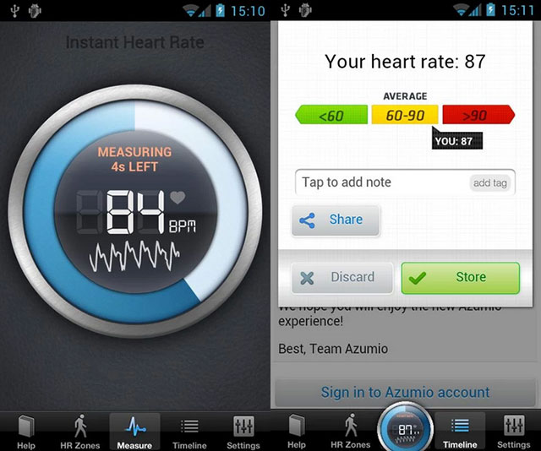

**Figure 2.1 Interface Instant heart rate apps**

* + 1. **Cardiograph**

Cardiograph uses your device's camera to measure your heart rate. The design is simple and clean, making it very easy to use. You can log data for multiple people with individual profiles all in one account. Track your heart rate over time to see how your fitness changes. Export your data to share with your health professional or keep for your own records. The Android app is designed to work with Android Wear smart watch pulse detectors as well.

Figure 2.2 show the interface of creating a client.

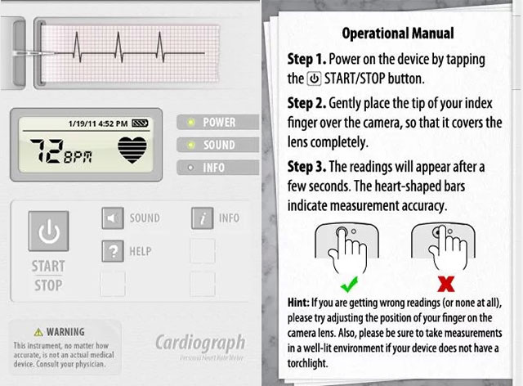

**Figure 2.2 Interface of cardiograph apps**

* + 1. **Runtastic Heart Rate Apps**

Runtastic Heart Rate app also uses the same technology like the previous apps. It uses the Camera sensor to measure your Pulse Rate. This free app will measure your heartbeat with great accuracy. You can see your HRM results in a graph. One of the best feature of this app is Stunning Interface that looks great on my Xperia Z. It offers variety of different, instant measurement types: resting HR, maximum HR, and HR before/after cardio

Figure 2.3 show the interface of creating form title.

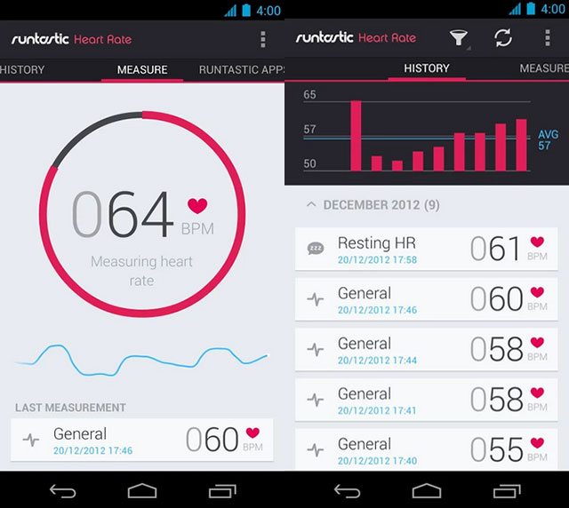

**Figure 2.8 Interface creating form title**

# **Comparison Feature Existing System**

|  |  |  |  |
| --- | --- | --- | --- |
| **Features** | **Instant Heart Rate** | **CardioGraph** | **Google Form** |
| Developer | azumio | Provide helps center to support user understanding. | Provide helps center to support user understanding. |
| Platform | Android  Ios | Ios | Flexible layout resolution. |
| Advantage | * Available for iphone and android * Fast to use * Storage and sharing options | * Easy to use, everything on one screen * Emailing and printing options * One can use either camera | * Auto save during editing the form. |
| Disadvantage | * Hard to use without a flash * Smudges the camera lens | * Difficult to get an accurate measurement right off the bat. | * Only user that have google account can use this form. |

**Table 2.1 Comparison of Features for three existing system**

# **Conclusion**

In this chapter, we already discuss about three existing system that similar with evaluation system. Then, we discuss the details of three existing system and their features to making a comparison. Base on the advantage and disadvantage from three existing systems, there are some features that we can use to develop this system.